Insert the cd-rom and open up the web page file titled, “home.html” Or, if the cd-rom is not available go to http://www.mrwaynesclass.com/circular/activity/home.html

Select “Ferris Wheel.” After the animation pops up press the “Play” button.

QUESTIONS AND PROCEDURE:
1.1) Use the stopwatch to measure the period of motion for the Ferris wheel. What is its period?

T =
1.2) Calculate it’s tangential velocity:

v =
1.3) Calculate its centripetal acceleration:

a_{C} =
1.4) If the mass of a rider is 65 kg, then what is the rider’s centripetal force?

F_{C} =
1.5) The term centripetal force is a generic term. If you were to talk about gravity, you would know that only mass exerts a gravitational force. But a “centripetal force” can be exerted by many different things. What is supplying the centripetal force to keep the rider going in a circle at the bottom of the motion?

Insert the cd-rom and open up the web page file titled, “home.html” Or, if the cd-rom is not available go to http://www.mrwaynesclass.com/circular/activity/home.html

Select, “Anti-Gravity Machine,” from the menu. Press the, “Play,” button when the animation opens up.

QUESTIONS AND PROCEDURE:
2.1) Use the stopwatch to measure the period of motion for the ride’s wheel. What is its period?

T =

2.2) Calculate it’s tangential velocity:

v =

2.3) Calculate its centripetal acceleration:

a_{C} =

2.4) If the mass of a rider is 55 kg, the what is the rider’s centripetal force?

F_{C} =
2.5) The term centripetal force is a generic term. If you were to talk about gravity, you would know that only mass exerts a gravitational force. But a “centripetal force” can be exerted by many different things. What is supplying the centripetal force to keep the rider going in a circle?

Insert the cd-rom and open up the web page file titled, “home.html” Or, if the cd-rom is not available go to http://www.mrwaynesclass.com/circular/activity/home.html

Select, “The Scrambler,” from the menu. Press the, “Play,” button when the animation opens up.

The “Scrambler’s” motion is a complex circular motion. When rider is the farthest away from the center, point B, the rider is moving with a speed equal to the tangential velocities about the minor axis AND the major axis. The rider’s radius is equal to the distance between his/herself, at point B, and the center. When the rider is closest to the center, point C, the rider experiences a velocity that is the difference between the major and minor axis. The rider’s radius is equal to the minor arm’s length.

QUESTIONS AND PROCEDURE:
3.1) What is the period of motion when the MINOR arm is the radius? T =

3.2) What is the tangential velocity when the MINOR arm is the radius?

v =

3.3) What is the period of motion when the MAJOR arm is the radius?
(Point B) T =

3.4) What is the tangential velocity when the MAJOR arm is the radius?

v =
3.5) What is the centripetal acceleration in g’s at point A? (When the major arm is the axis.)

a_{C} =

Insert the cd-rom and open up the web page file titled, “home.html” Or, if the cd-rom is not available go to http://www.mrwaynesclass.com/circular/activity/home.html
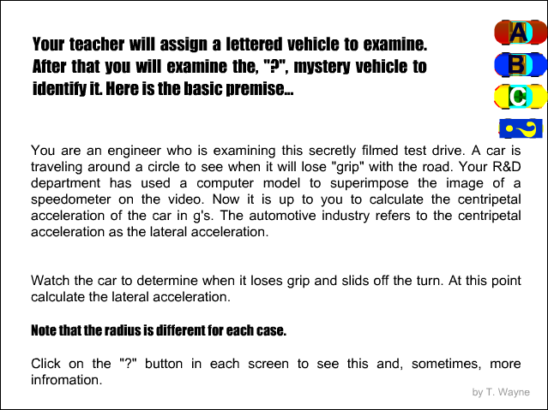
Select, “Cars and Cornering,” from the menu.

The animation’s title screen explains the situation. READ IT. When you watch the clips, remember, the speedometer you see is in m/s and it is based on a computer model of the video clip. That’s why when the car spins of the track the speedometer does not change.

4.1) Which clip were you assigned?_________

The radius is given on the “video clip.”

4.2) Watch the “video clip” and observe when the car loses traction and slides off the track. Record the speed at which this happens.
v =

4.3) What is the lateral acceleration of the car in g’s?

a_{C} =
  - Now click on the question mark button.
This will take you to the mystery car.
For this car you are going to calculate the lateral acceleration and compare it to a table to determine which car is under the question mark. (Note, the track’s radius has changed.) Which car do you have under the question mark? Show support for your answer.
Car Name | Lateral  Acceleration  In g’s
LexusGX 470 | 0.72
Lexus ES300 | 0.76
Lexus GS300 | 0.80
Lexus S300 Sport Cross | 0.82
Answer: __________________
4.5) Draw the path of the mystery car when it spins off the track at the location where is comes off the track.

Insert the cd-rom and open up the web page file titled, “home.html” Or, if the cd-rom is not available go to http://www.mrwaynesclass.com/circular/activity/home.html

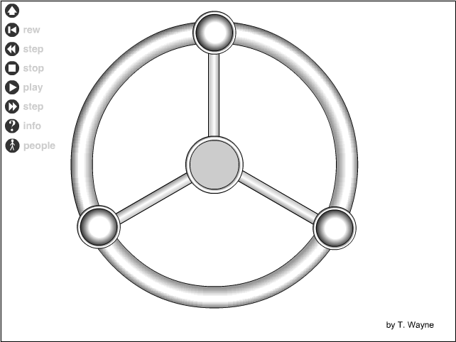
Select, “Space Station,” from the menu.

Note: This is nothing like the I.S.S. currently being built. It is the typical science fiction design I remember reading about as a kid.

5.1) Using the stop watch measure the period of motion of the space station.

T =
5.2) Click on the “people” button,
to see where a person would stand to experience “artificial gravity.” Why do you think standing here would give a passenger the feeling of standing on a planet?

5.3) What would the radius at the edge of the outer ring have to be for the centripetal acceleration equal to 1 g on Earth?

r =
5.4) Then center compartment of the space station has a radius that is 1/5th the radius to the edge of the outer ring. If the centripetal acceleration replaced the acceleration due to gravity (artificially), then how much time would it take for a pen to hit the floor if it was dropped from 1.00 m above the floor?

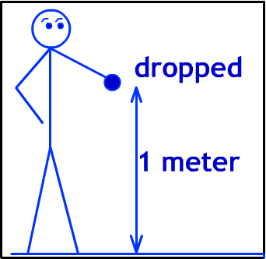

t =
5.5) How many g’s would a passenger experience in the exact center of the space station? Explain your answer.

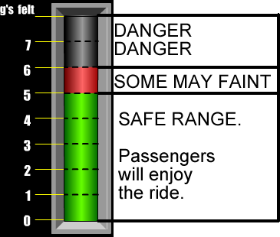
Insert the cd-rom and open up the web page file titled, “home.html” Or, if the cd-rom is not available go to http://www.mrwaynesclass.com/circular/activity/home.html

Select, “Loops (Design),” from the menu.

Click on LOOP A from the menu screen.

The meter on the right of the animation shows the g’s felt on the seat of the rider. This is called a force factor. It describes the amount of weight felt by a rider. 2 g’s is twice the normal weight.

Press the play button and watch the “g’s felt” meter. Keep in mind the ranges. For ever animation the coaster’s velocity is the same
LOOP A

6.1) Where in the motion does the rider feel 1 g?

  - How many g’s does the rider feel as he enters the loop at the bottom?
  - How many g’s does the rider feel as he passes through the top of the loop?
  - Is this loop safe or unsafe for its passengers?
  - Explain

  - Look at the formulae on the left of the screen. Given that the speed of the coaster cannot be changed, how can the loop physically be altered to reduce the g’s felt by the rider AT THE BOTTOM OF THE LOOP?

LOOP B

Click on LOOP B at the bottom of the animation. Click on play to see what happens.
  - How many g’s does the rider feel as he enters the loop at the bottom?
  - How many g’s does the rider feel as he passes through the top of the loop?
  - Why does the rider behave this way at the top of the loop?

  - Look at the formulae on the left of the screen. Given that the speed of the coaster cannot be changed, how can the loop physically be altered to increase the g’s felt by the rider AT THE TOP OF THE LOOP?

LOOP C

Click on LOOP C at the bottom of the animation. Click on play to see what happens.
6.11) What is the name of this loop?
6.12) Does this loop design solve problems with the small and large loop? _____
6.13) Explain

LOOP D

Click on LOOP D at the bottom of the animation. Click on play to see what happens.
6.14) What is the name of this loop’s shape?
6.15) Compare LOOP C and LOOP D, Which is a better solution to the problems with small and large loops (A & B)?
6.16) Explain

Insert the cd-rom and open up the web page file titled, “home.html” Or, if the cd-rom is not available go to http://www.mrwaynesclass.com/circular/activity/home.html

Select, “Kidsville’s ford GTX Ride,” from the menu.

Use the cursor to measure R₁ and R₂.

8.1) Calculated the centripetal acceleration of the cars on the outside of the ride.

Outside car’s a_{c}:

8.2 ) Calculate the centripetal acceleration of the cars on the inside of the ride.

Inside car’s a_{c}:

Insert the cd-rom and open up the web page file titled, “home.html” Or, if the cd-rom is not available go to http://www.mrwaynesclass.com/circular/activity/home.html

Select, “Target Practice” from the
menu.

Follow the instructions and try your skills on slow, medium and fast speeds.

9.1) How does this exemplify the concepts we discussed early in the unit? Use complete sentences.

